A Total Brain Framework for AGI: An Overview
April 2026
Authors: Evian Gordon, MBBCh PhD^{1*}, Donna Palmer, PhD¹, Anne Clarke, BS¹
¹ Total Brain, A SonderMind Company
*Correspondence: evian.gordon@totalbrain.com.
Human Brain Cognition and Emotion are becoming an increasingly present source of inspiration within the AGI field. This shift is visible across frontier labs and leading researchers.
AGI development is currently experiencing a period of pivot and change as it considers new approaches to the development of Artificial General Intelligence (AGI) and the ‘jaggedness’ problem. AI development has been in many ways incredible and can do some things extraordinarily well, yet continues to struggle below human ability in others. True AGI is positioned as future AI models that will achieve at or above human ability in ‘smooth’ way, being equally good across all relevant performance domains. Current approaches to AI development, which have in many areas achieved unprecedented AI abilities, have not yet met the promise of true all-round ‘smooth’ AGI. Many leading AI labs acknowledge the potential of the human brain to provide differentiating inspiration and direction for new approaches to AGI development (e.g. Altman, 2025; Hassabis et al., 2017; LeCun 2022).
We propose a new complementary framework from an integrative neuroscience perspective that is informed by the Total Brain Database: The Total Brain Integrative Intelligence Framework for AGI (TBII-AGI). The essential components of TBII-AGI posits that human brain and performance data: (1) Has utility to inform for AGI development; (2) Can uniquely inform ‘signatures’ of smooth all-round general performance; (3) Contains emotion-cognition interactions relevant to AI; (4) Reveals essential processes of unconscious cognitive efficiencies and cognitive biases relevant to AI; (5) Provides consideration of whole-brain system dynamics and hierarchical structures that give rise to human-like general intelligence.
While there are fundamental ways in which AI and human intelligence will always be different, we posit that there are also many areas of similarity which hold untapped potential for AGI development. We give here exemplars of four such areas from the TBII-AGI perspective and posit the potential utility for large integrative neuroscience datasets, such as that in the Total Brain Database, to offer unique insights for new approaches to AGI development.
1. Google DeepMind’s recent cognitive framework for AI, “Measuring Progress Toward AGI: A Cognitive Taxonomy,” collates human cognitive domains most relevant for intelligent behavior, as a benchmark system for tracking when AI models meet and surpass the full spectrum of human abilities (Burnell et al., 2026). Using human data from the Total Brain Database on equivalent cognitive constructs to the Google DeepMind Cognitive Taxonomy, we have demonstrated that human-equivalent profiles of ‘jagged’ and ‘smooth’ performance can be identified, from people with average to high performance across categories. We suggest that ‘smoothness’ of cognitive profile may reflect a distinct strategic approach or underlying neural mechanism that generalizes across cognitive efforts. Further exploration of database data down to the single-trial behavioral performance and neural responses level has the potential to identify a ‘signature’ of smooth performance that could be informative for new approaches to development of AGI.
2. Emotion and cognition are inextricably linked in humans. Emotion processes function as core guidance and motivational systems for human behavior, assigning significance levels and directing attention and other cognitive resources. For example, ‘gut feelings’ play a strong role in complex decision-making, acting as an efficient unconscious shortcut to integrate previous learning experiences into current decision-making (Bechara and Damasio, 2005). Relationships between emotion and cognitive performance are also emerging as relevant for large language models (LLMs). Recent research from Anthropic reported LLMs to change decision-making behavior along with strength of the emotion state they are displaying in similar ways to what would be expected for humans, such as sensible decisions when ‘calm’ and more unexpected or deviant decisions when ‘desperate’ (Sofroniew et al., 2026). We posit that the highly complex data on human cognitive, emotional, and personality traits, such as that in the Total Brain Database, can be leveraged to better understand the interplay between these aspects of cognition and intelligent performance in a way that may be insightful for AGI development.
3. Unconscious Bias and Cognitive Interference in AI: Unconscious processes constitute the human brain’s ‘fast’ system, rapidly evaluating new information for potential threat or significance, and preparing slower conscious cognitive systems accordingly (Gordon, 2025). However, the operation of these two cognitive systems also necessarily creates cognitive biases in current thinking towards previously well-learned associations, with over 100 cognitive-emotion biases representing one of the most robustly documented features of human cognition and one of the most underexplored dimensions of AI evaluation. Using data from the Total Brain Database and a new Vision Language Model, we have demonstrated analogous color-word stroop bias in humans and AI – both showing the cognitive bias interference effect in naming font color, only when the word presented is a color word different from the font color that it is presented in. This suggests similarities in cognitive bias and interference across both AI and human performance, and that unexplored nuances of human performance and unconscious cognitive functions may further inform these types of effects in AI models.
4. Objective, time-locked electrical brain-function Event-Related Potentials (ERPs) from the Total Brain Database track (in a fraction of a second) correct responses and error detection while solving an Executive Function Maze Test that is heavily dependent on adaptive learning and akin to some of the ARC-AGI-3 benchmarks. These ERPs provide a direct, dynamic real-time insight into some of the underlying electrical brain functions of how a person learns, including their learning rate, style, performance level, and how well they adapt during the task. In the AI development context, ERP components have been postulated to have functional similarities to component aspects of AI models, with some suggesting that LLM surprisal may explain ERP components in humans (Michaelov et al., 2023). ERP components relating to prediction errors and deviant stimuli may also have unique potential to inform AI neural-based models that are also framed around predictive processing (LeCun, 2022).
This Total Brain TBII-AGI framework is presented as a complementary deepening and expansion of the existing direction of AGI testing and development, by incorporating a spectrum of brain-emotion capacities, unconscious-conscious processes, and temporo-spatial-response time performance, in a 7 billion datapoint standardized human-brain -database. It illustrates a path to AGI that genuinely complements human intelligence, requires measuring the full architecture of human cognition, emotion, and functional adaptive dynamics, not just its highest-visibility peaks.
For the full version of this paper see https://totalbraindatabase.com/ai
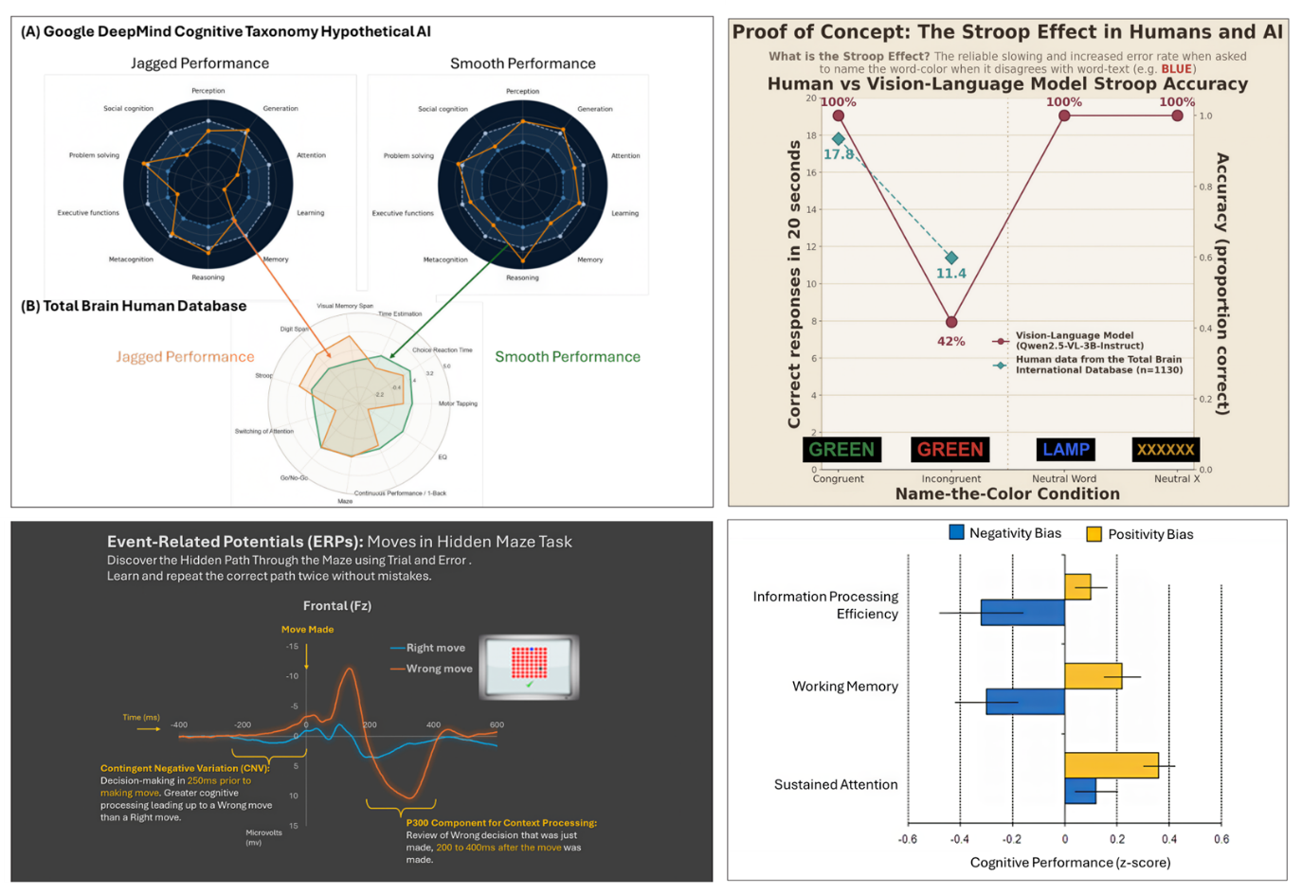
Figure: Top Left: Demonstration of equivalent jagged and smooth performance profiles across cognitive domains between Google DeepMind hypothetical AI models (Burnell et al., 2026) and Total Brain Database human performance data. Top Right: Performance on the color-word stroop task shows a similar interference effect when the font color and word text are incongruent (different) colors in AI (VLM) performance and human data from the Total Brain Database. Bottom Left: Event-related potentials from the Total Brain Database in response to right (blue) and wrong (red) moves in a hidden maze task, displaying greater “preparatory state” Contingent Negative Variation (CNV) and “mismatch P300” responses to wrong moves. Bottom Right: Total Brain Database normative cohort data showing worse cognitive performance in people who are more negatively biased (Gordon et al., 2008).
References
Altman, S. (2025). The gentle singularity. Sam Altman. https://blog.samaltman.com/the-gentle-singularity
Bechara, A., & Damasio, A. R. (2005). The somatic marker hypothesis: A neural theory of economic decision. Games and Economic Behavior, 52(2), 336–372. https://doi.org/10.1016/j.geb.2004.06.010
Burnell, R., Yamamori, Y., Firat, O., Olszewska, K., Hughes-Fitt, S., Kelly, O., Galatzer-Levy, I. R., Ringel Morris, M., Dafoe, A., Snyder, A. M., Goodman, N. D., Botvinick, M., & Legg, S. (2026, March 16). Measuring progress toward AGI: A cognitive framework [Technical report]. Google DeepMind.
Gordon, E (2025). The Brain Way. Franklin Publishing
Gordon, E., Barnett, K. J., Cooper, N. J., Tran, N., & Williams, L. M. (2008). An “integrative neuroscience” platform: Application to profiles of negativity and positivity bias. Journal of Integrative Neuroscience, 7(3), 345–366
LeCun, Y. (2022). A path towards autonomous machine intelligence (Version 0.9.2). OpenReview. https://openreview.net/pdf?id=BZ5a1r-kVsf
Michaelov, J. A., Bardolph, M. D., Van Petten, C. K., Bergen, B. K., & Coulson, S. (2023). Strong prediction: language model surprisal explains multiple N400 effects. Neurobiology of Language, 5(1), 107–135. https://doi.org/10.1162/nol_a_00105
Sofroniew, N., Kauvar, I., Saunders, W., Chen, R., Henighan, T., Hydrie, S., Citro, C., Pearce, A., Tarng, J., Gurnee, W., Batson, J., Zimmerman, S., Rivoire, K., Fish, K., Olah, C., & Lindsey, J. (2026). Emotion concepts and their function in a large language model. Transformer Circuits Thread. https://transformer-circuits.pub/2026/emotions/index.html

